|  |
| --- |
| **JDN Standards – Deployment VM clients** |

Introduction 1

Guidelines 1

Software installed on VM clients on board 1

Configure Outlook 1

# Introduction

This document provides guide lines for deployment of VM clients within the JDN Standards for Vessels as defined in 2015. These virtual machines are hosted by the server infrastructure of the vessel.

# Guidelines

## Software installed on VM clients on board

* JDN Core software NON DOMAIN
* ESET antivirus
* Replication software that is in use on the vessel (AMOS, ICat, EPOS, …)

On the MGMT and the AMOS client install the last company used version of TeamViewer.

## Configure Outlook

Configure outlook to get the mails from the commbox on board of the vessel.

* Create a new mail profile with the name of the user (captain, elec, chief, …)
* Use the IMAP and “Commbox” as mail server  
  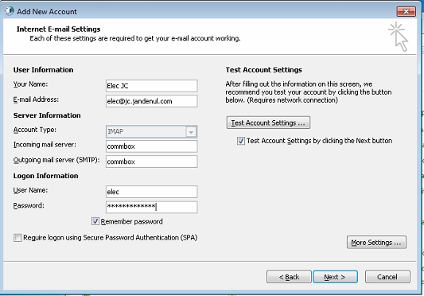
* If the mailbox doesn’t exist on the commbox, create them first.
* Rename the name of the mailbox and the archive pst.  
  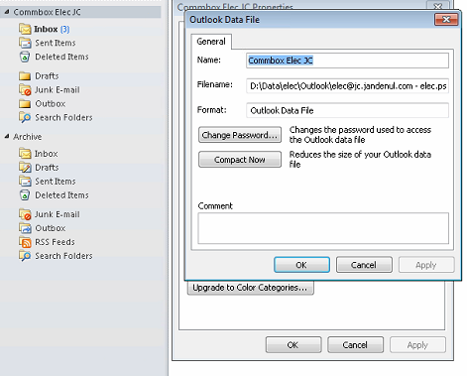
* Import the JDN contact list
  + Download the csv from <http://vm-web02> (CSV File - comma)
  + In Outlook: Open > Import > Comma separated values (windows)
  + Select file
  + Destination: Contacts